Step 0 Intake + Interview Filing Status, Dependency

Interview Notes: (See also: General Notes)
- Shirley worked part time to earn spending money.
- Shirley is single and living with her parents while she attends college full time.
- Shirley is totally supported by her parents and her parents will claim her as a dependent on their return.

Documents:

Step 1 Basic Information
TP Form / Note | TS Screen | Notes
SS Card | Start a New 2018 Tax Return  Available Taxpayer Profiles | Ignore the Profiles  Select “Enter Social Security Number” at the bottom of the screen. SSN format YYY-00-0752  Enter the TP SSN twice and “Start Return”
Intake Sheet | What is your filing Status? | TS Answer: Single  TS: “Continue”
SS Card  Intake Sheet  I-Notes 2,3 | Personal Information  Taxpayer Information  Address & Phone Number | Hint: Enter all information using “Caps Lock”  Hint: Use Name and SSN from SS card. (Not Intake Sheet)  Hint: SSN format YYY-00-0752  TS: Birth date can be entered using drop down menu or filling in the field.  TS: Check any of the “Check here” questions that apply:  - Can be claimed as a dependent on someone else’s return  - Is claimed as a dependent on someone else’s return  - Over 18 and full time student  - TP wishes to contribute $3 to the Presidential Election Campaign Fund  TS: Enter Zip code- TaxSlayer fills in city and state. Correct if required  Hint: Did you enter the apt. number?  TS: New Jersey will default as the Resident State.  TS: “Continue”
Intake Sheet | New Jersey Return  NJ Property Tax Credit or Deduction  Do you meet Property Tax  Credit or Deduction  Eligibility Requirements?  Taxpayer NJ Health Insurance  Does the Taxpayer have  Health Insurance?  New Jersey Return  Select the County or  Municipality of your  current residence | Start the NJ Checklist at this time  TS Answer: At this point answer “No”. We will go back and adjust after the Federal Return is complete  TS Answer: “Yes”  Use “NJ Municipality Code lookup in Tax Prep 4 Free  Left click in the box. Type in Ocean. Scroll down to OCEAN – STAFFORD TOWNSHIP  At this point just hit ““Continue”” We will go back and adjust after the Federal Return is complete
 | Dependents or Qualifying Child Information  Do you have any Dependents or Qualifying Person(s) to claim on your return? | TS: Answer is “No”

Federal AGI: 0 Federal Refund: 0 NJ Refund Amount: 0
Step 2 W-2 The Kansas City Steak House
W-2  The Kansas City Steak House | Left Menu - Federal Section  Income  Wages & Salaries Form W-2  Begin  Complete W-2 Information- | Hint: Make corrections so that information matches the information on the paper W-2  - Add Apt 6A to address.  - If the name and address of the employer come up after inputting the employer Identification Number, check that the information matcher the paper W-  Hint: Always round up for cents amounts ending in .50 or enter cents and TS will round it for you  Hint: Box 14 NJ Codes are selected from drop down menu. All other entries in box 14 are lumped under “Other”  Hint: If NJ State EIN auto populates, check to be sure it is correct  TS: “Continue”
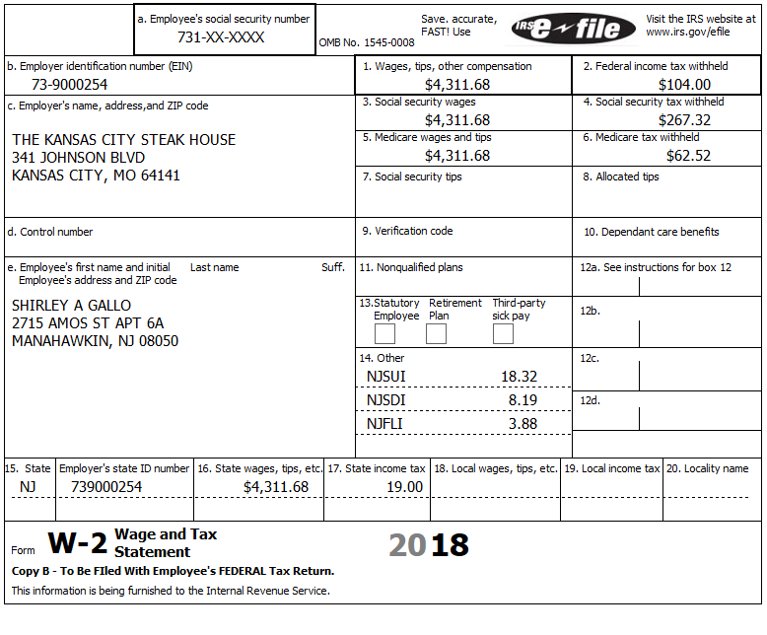

Federal AGI: 4,312 Federal Refund: 104 NJ Refund Amount: 19
Step 3 Interest 1099-INT
1099-INT  Big Bank | Federal Section  Income  Interest and Dividends Form 1099-INT/ 1099-DIV- Begin  Interest or Dividend Income -Begin  Interest Income, Form 1099-INT – “Select”  “Continue” | Enter values that apply  Hint: Since the interest is tax exempt both Federal and State, there is no adjustment required for the State.  “Continue”

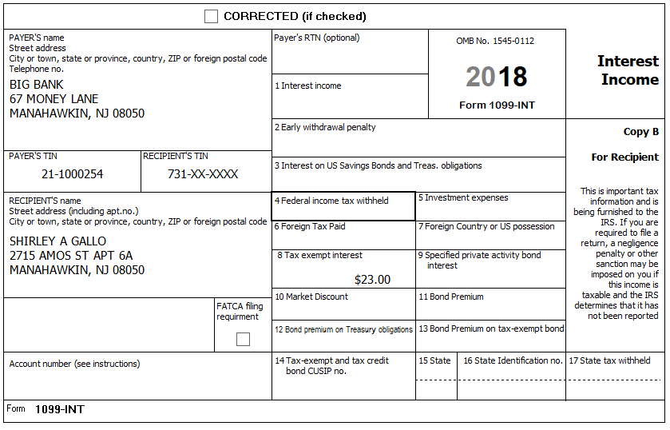

The tax-exempt interest received was from a NJ Turnpike Bond and it is tax exempt in NJ.

Federal AGI: 4,312 Federal Refund: 104 NJ Refund Amount: 19
Step 4 Itemized Deductions – Taxes You Paid
TP Form / Note | TS Screen | Notes
I-Note 4 | Left Menu-Federal Section -Deductions – Enter Myself  Itemized Deductions – Begin  Taxes You Paid - Begin | TS: Go to ADD SALES TAX WORKSHEET and enter ZIP Code and 365 days living in NJ  ““Continue””

Federal AGI: 4,312 Federal Refund: 104 NJ Refund Amount: 19

Step 5 Compare Standard vs Itemized Deductions

TP Form / Note | TS Screen | Notes
 | Federal Section  Deductions  Enter Myself  Compare Deductions - Begin | Check to see if using itemized or standard deductions.  Itemized = 49  Std = 4,662  Hint: You can view Schedule A (Itemized Deductions) by clicking on the Print Icon next to Itemized Deductions in the Deductions Menu.  “Continue”

Federal AGI: 4,312 Federal Refund: 104 NJ Refund Amount: 19
Step 6 Health Insurance
TP Form / Note | TS Screen | Notes
G-Note 2 | Left Menu-Health Insurance  Health Insurance Questionnaire  Did you or your family have health insurance or qualify for a coverage exemption at any time in 2018?  “Continue”  Did you purchase insurance via HealthCare.gov of a State Marketplace?  “Continue”  Verify Your Household Members  “Continue”  Months Insured  Was your entire household covered by qualifying health care coverage or a coverage exemption that covered 2018 or a combination of qualifying health care coverage and coverage exemptions for every month of 2018? | Answer questions in the Health Insurance Section  TS – Yes  TS – No  TS – Always select ““Continue””  TS-Yes  “Continue”

Shirley is totally supported by her parents and her parents will claim her as a dependent on their return.

Federal AGI: 4,312 Federal Refund: 104 NJ Refund Amount: 19

Step 7 New Jersey Return

TP Form / Note | TS Screen | Notes
I-Note 2,3  G-Note 2,3,4 | State Return –Edit  Basic Information - Edit | Hint: Use the NJ Checklist to enter NJ items  TS: Complete Basic Information.  Hint: Gubernatorial Election Fund: Shirly - Yes  “Save  Save back to the beginning of the State Return

Federal AGI: 4,312 Federal Refund: 104 NJ Refund Amount: 19
Step 8 Prepare for e-file

Intake Sheet  G Note 5 | Left Menu – e-file –  Federal Return Type  Fees  State Return Type  Third Party Designee Info  Consent to Disclose  Questions  Taxpayer ID Information – | TS – Clear up any diagnostic messages (if any)  TS: Select “E:file: Paper Check”  Next  TS: No entries in Fees section except for Client email address  Next  TS: Select State Refund Type “E:file: Paper Check”  Next  TS: Skip Third Party Designee. It is Out of Scope for us.  Next  TS: Consent to Disclose Tax Return Information – Check GRANT  and enter 5 digit pin (any 5 digit number) and date for TP.  Next  TS – Questions – Answer questions from Intake sheet Part VII, lines 5.6,7 and 8  - Assume taxpayer was present  Next  TS: Skip TP ID Information Screen. Not required for NJ.  Save  You are Done

She wants to handle any state refund / amount due like their federal refund / amount due.

Federal AGI: 4,312 Federal Refund: 104 NJ Refund Amount: 19

